Formative and Summative Assessment - Pre and Posttest
Name: ______________________________
Photosynthesis
Part 1: MULTIPLE CHOICE
- What is photosynthesis?
- The process in which plants eat other plants
- The process in which plants make food
- A kind of plant
- A kind of gas produced when plants grow

- What gas do plants give off to help humans breathe as a result of photosynthesis?
- Helium
- Carbon dioxide
- Nitrogen
- Oxygen

- What does sunlight do for plants during photosynthesis?
- Provides the plant with energy
- Provides the plant with air to breathe
- The sunlight does not do anything for plants
- Provides the plant with a blanket to stay warm

Part 2:
4. CIRCLE ALL OF THE PICTURES THAT SHOW WHAT A PLANT NEEDS FOR PHOTOSYNTHESIS TO TAKE PLACE.

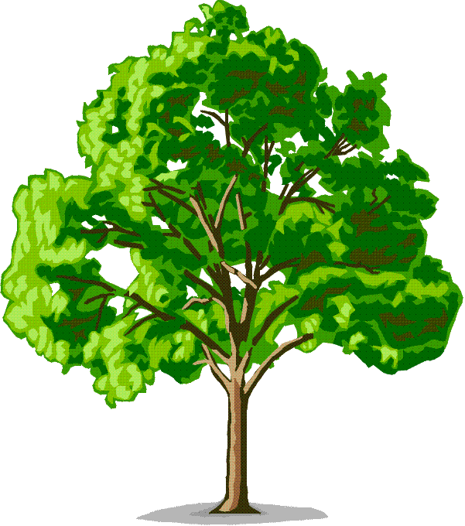

  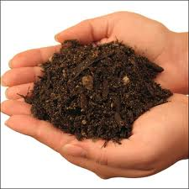 (Soil)
Part 3:
5. Circle which plant photosynthesis is taking place.
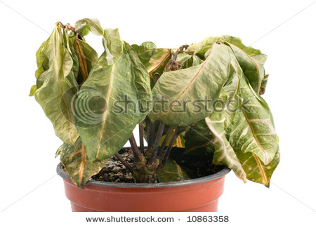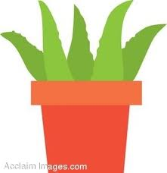
Part 4:
6. What are three things that people get from plants?
__________________________________________________________________________________________________________________________________________________________________________________________________________________________________________

